Engineering Management Department
PM User Guide
--TD Management System

Written by：Yang Ming Xia  Date：2014-3-26 | Checked By:  Date:

Content

1. User login and logout - 1 -
1.1 Login system - 1 -
1.2 Main interface - 2 -
1.3 Logout system - 3 -
2. Add Project (Engineer) - 4 -
2.1 Click "PROJECTS" on the tabular menu bar - 4 -
2.2 Click "Add Project…" - 4 -
2.3 Attachment - 5 -
3. Apply for project appraisal (Engineer) - 7 -
3.1 Locate project - 7 -
3.2 Click ”Apply for appraisal” button - 8 -
3.3 Input the notation messages - 8 -
3.4 Upload Attachment - 9 -
4. Evaluating a project (appraiser) - 10 -
4.1 Locate project - 10 -
4.2 Start to appraise - 11 -
4.3 Enter appraisal workload - 11 -
4.4 Input the notation messages - 12 -
5. Start a project (Engineer) - 12 -
5.1 Locate project - 12 -
5.2 Execute "Start a project" wizard - 13 -
5.3 Input planning submit date - 13 -
5.4 Input the notation messages - 14 -
5.5 Attentions after started - 14 -
6. Selftest promise (Engineer) - 15 -
6.1 Locate project - 15 -
6.2 Execute "Selftest promise" wizard - 15 -
6.3 Confirm selftest promise - 16 -
7. Submit to audit (Engineer) - 16 -
7.1 Locate project - 16 -
7.2 Execute "Submit to audit " wizard - 17 -
7.3 Confirm before submit - 17 -
7.4 Input platform version - 18 -
7.5 Input engineering version - 18 -
7.6 Confirm version named specification - 18 -
7.7 Select the package to test - 19 -
7.8 Input SVN URL - 19 -
7.9 Input Dailybuild URL - 19 -
7.10 Input required to complete days - 19 -
7.11 Input machine model to test - 20 -
7.12 Reconfirm all message - 20 -
7.13 Enter the notation - 20 -
7.14 Upload Attachment - 21 -
8. Code review (Code reviewer) - 22 -
8.1 Locate project - 22 -
8.2 Start code review - 22 -
8.3 Finish code review - 23 -
8.4 Upload Attachment - 24 -
9. Internal Test (Tester) - 25 -
9.1 Locate project - 25 -
9.2 Start internal test - 26 -
9.3 Finish testing - 27 -
9.4 Upload Attachment - 28 -
10. Apply for beta release (Engineer) - 29 -
10.1 Locate project - 29 -
10.2 Execute apply for beta release wizard - 29 -
10.3 Upload Attachment - 31 -
11. Beta release (CM) - 32 -
11.1 Locate project - 32 -
11.2 Execute beta release wizard - 33 -
12. Apply for general release (Engineer) - 33 -
12.1 Locate project - 33 -
12.2 Execute apply for general release wizard - 34 -
12.3 Upload Attachment - 35 -
13. General release (CM) - 36 -
13.1 Locate project - 36 -
13.2 Execute general release wizard - 37 -
14. The usage of the convenient tools - 37 -
14.1 Flag for follow up - 37 -
14.2 Set the Filter/Sort. - 40 -
15. Problems and Solutions - 43 -
15.1 How to solve the problem TD email is regarded as the spam email. - 43 -
15.2 The ways to solve the problem that it cannot login TD using higher version IE. - 44 -
15.3 The solution to solve the problem that it cannot install TD control plug-in under the Browser with the WIN7/VISTA OS environment. - 47 -
15.4 Modify the fields in TD, but the content is not updated. - 48 -
15.5 When updating data, the data is locked by other user. - 48 -
15.6 The content of the TD Email is garbled data. - 49 -
15.7 The reason and solution of the "Access violation" problem. - 49 -
15.8 How to find your information quickly. - 49 -

User login and logout

1.1 Login system
1. Can use VPN to log in system when not in the company.
2. login in the following step
(1) TD website: http://10.1.3.119/tdbin/start_a.htm
(2) Select Domain: ISD
(3) Select Project: PM
(4) Input your User ID
(5) Input your Password
(6) Click [Login].
User ID is same as the mailbox name and the password is same as the Project Management TD’s password.The default password is blank. (Please modify the password in time).
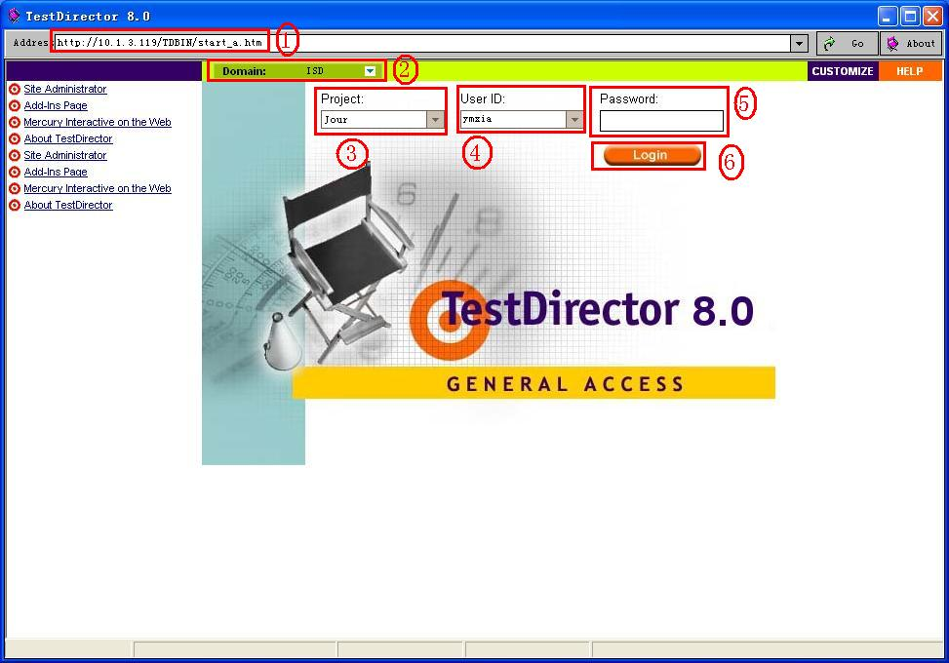

1.2 Main interface
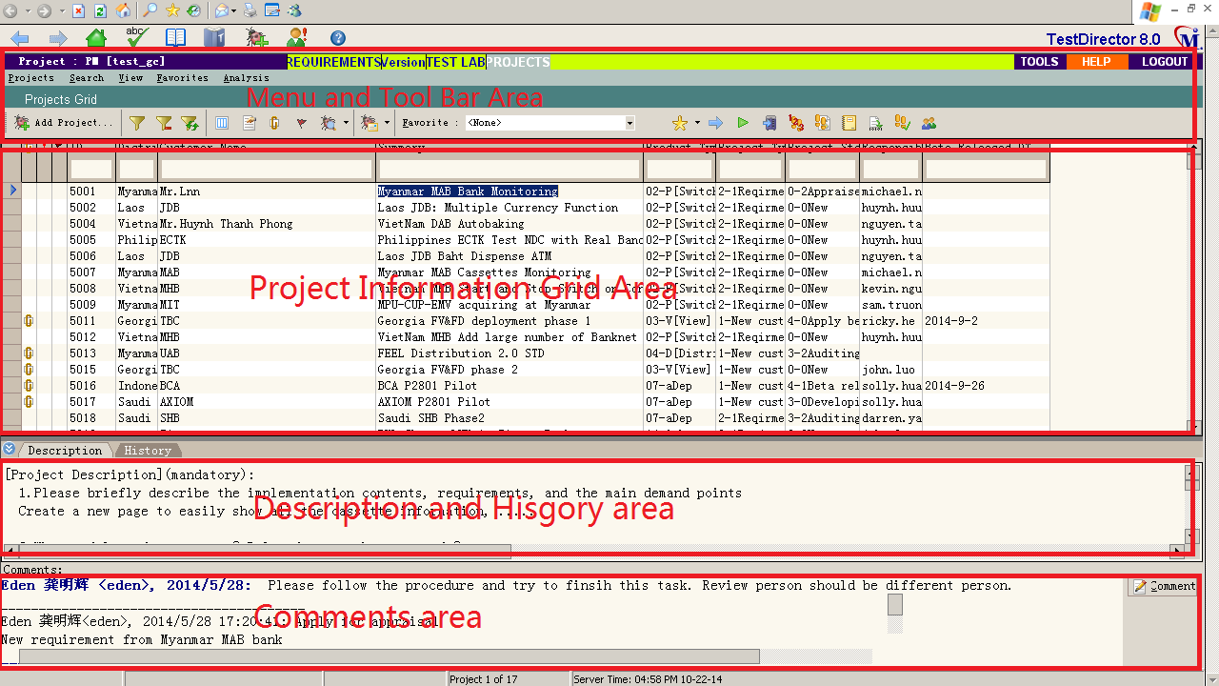

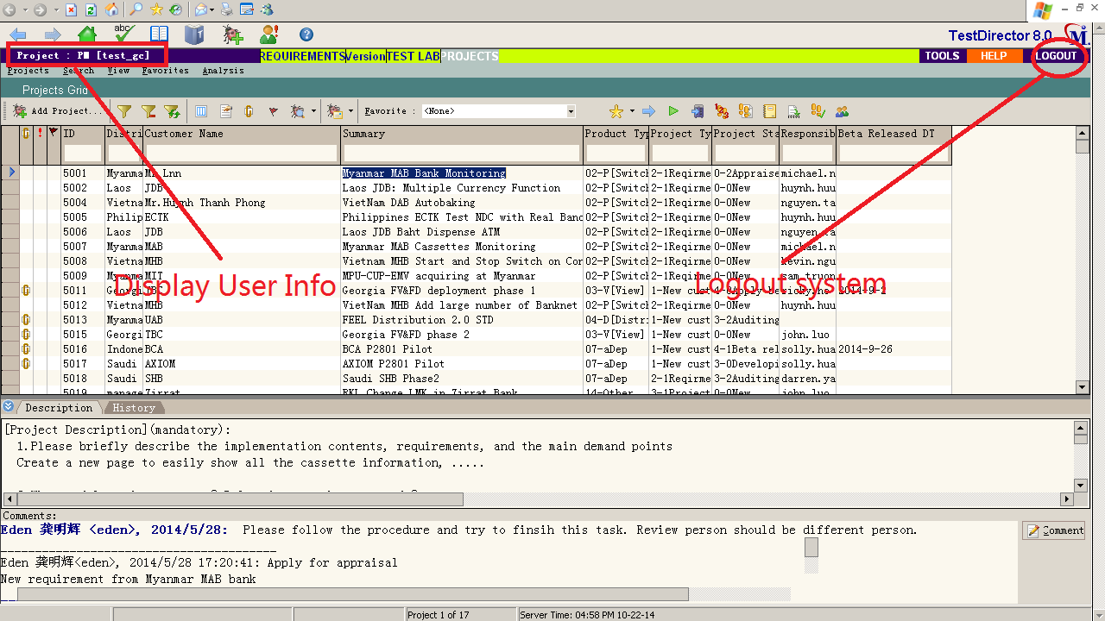

1.3 Logout system
After logging in system, user must click [LOGOUT] to log out the system. If log out the system abnormally, it may happen that user cannot log in the system or the database is locked by itself when logging in the system next time.
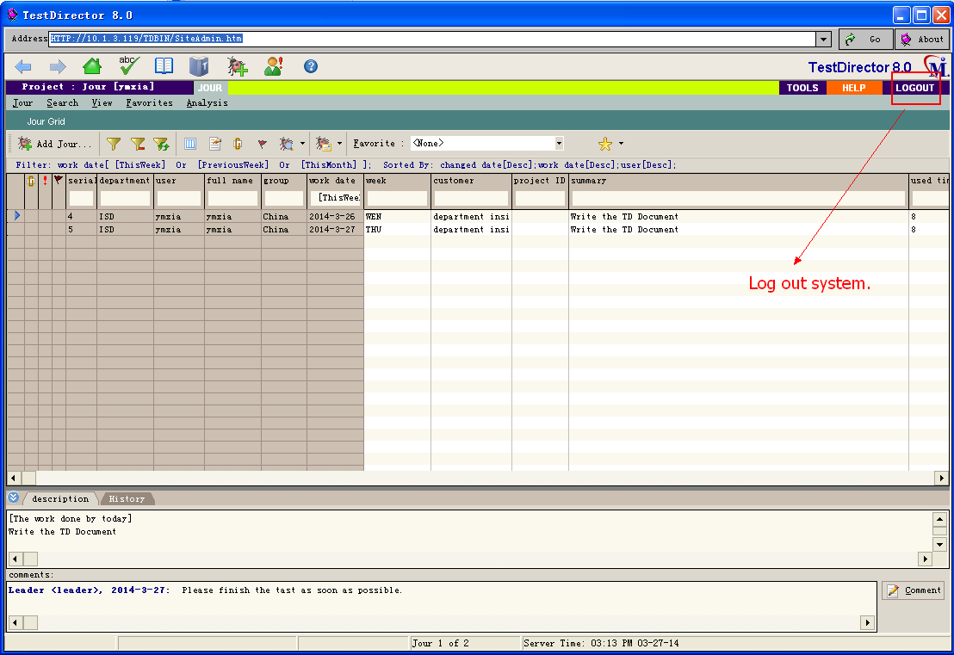

Add Project (Engineer)

2.1 Click "PROJECTS" on the tabular menu bar
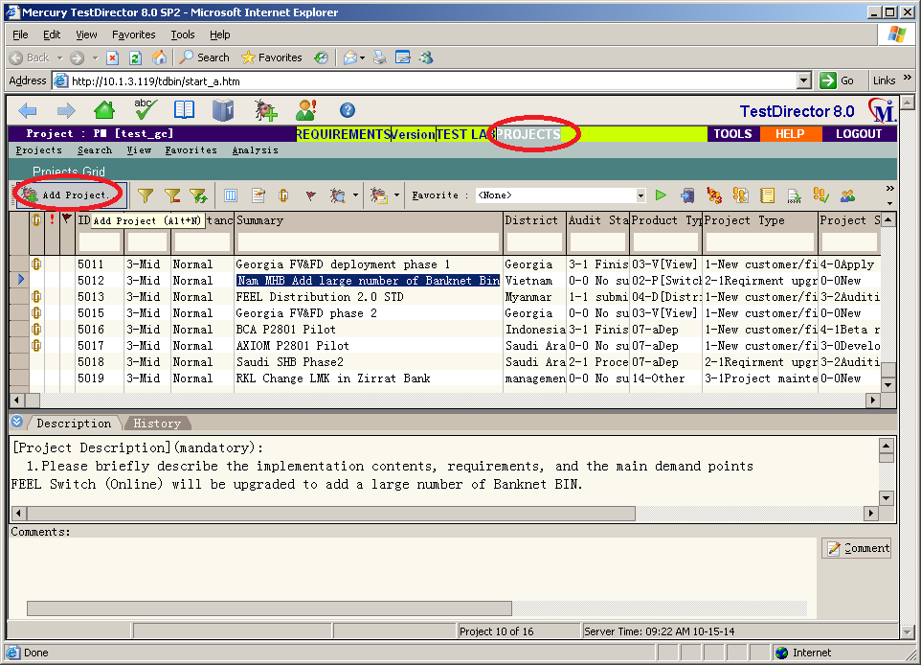

2.2 Click "Add Project…"
2.2.1. Click "Add Project..." button to add a new project information: 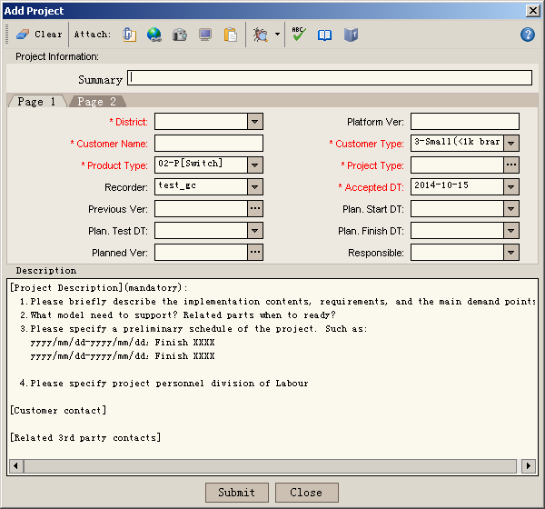
Brief description: "Customer name +Main requirement"
Write the description about the project requirement or plan in this area.
Click this button to ignore this action and close this dialog.
Click this button to submit the form. The content will be saved.

2.3 Attachment
Can upload the document related to the work to the server if necessary.
Step 1: Click [Attach:] on "Add Project" dialog.
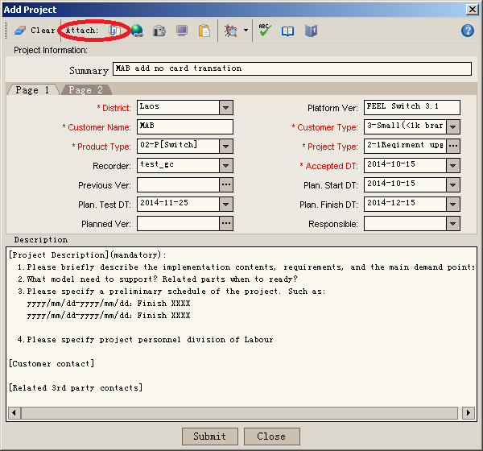
Step 2: Select the document to upload.
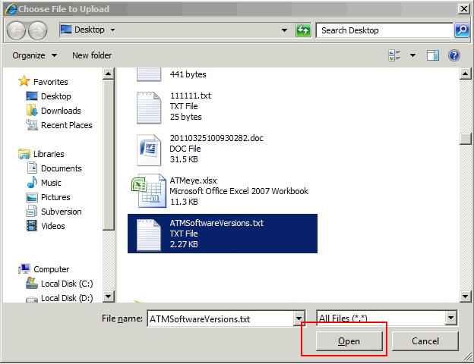

Apply for project appraisal (Engineer)
In principle project which requires code modification or work more than 2 man-day, should be evaluation before setup.
TO the tiny project that lease 2 man-day or need not code modification project, can startup directly.

Locate project
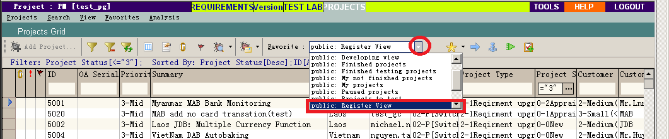
Click the drop down list of the favorite, and select the “Register View”.
Find your project and move the cursor bar to the record.

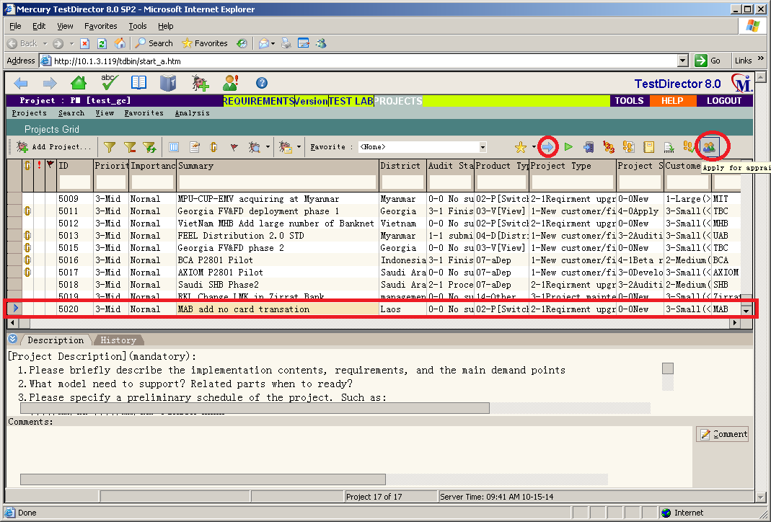

Click ”Apply for appraisal” button
Click “Next Step” or ”Apply for appraisal” button, the screen display as follow:

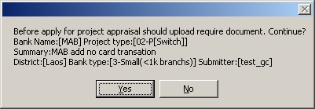
When you click “Yes” the project state will change to “Appraising” status.

Input the notation messages

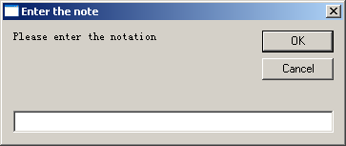

Upload Attachment
You can upload the document related to the project to the server if necessary.
Step 1: Click icon on the menu bar
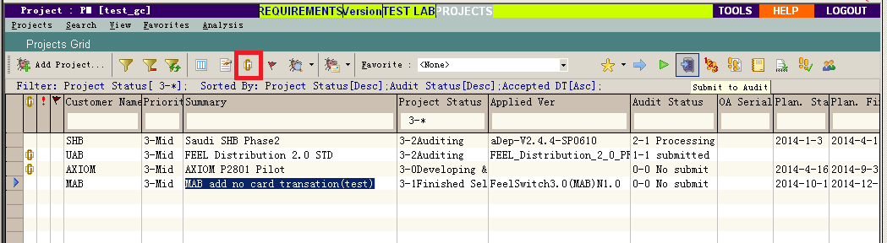

Step 2: Select the document to upload.

Evaluating a project (appraiser)
When a project is submitted to apply for project appraisal, the project evaluation expert group members will demand for project appraising, according to the project requirement make assessment of the work required, risk, etc.
The appraiser need to check the documents and information that submitted by the engineering staff, whether the document is clear and the project plan is reasonable, what are the risks, and according to the requirement assessment templates, reference to history project implementation experience, to evaluate the project.
Such as unclear project requirements, the document is not complete, demand is not reasonable, or there is a big project risk, appraiser will indicate in the TD remarks field, and refused to project evaluation.

Locate project
The appraiser login to TD system.
Click the drop down list of the favorite, and select the “Register View”.
Find your project and move the cursor bar to the record.

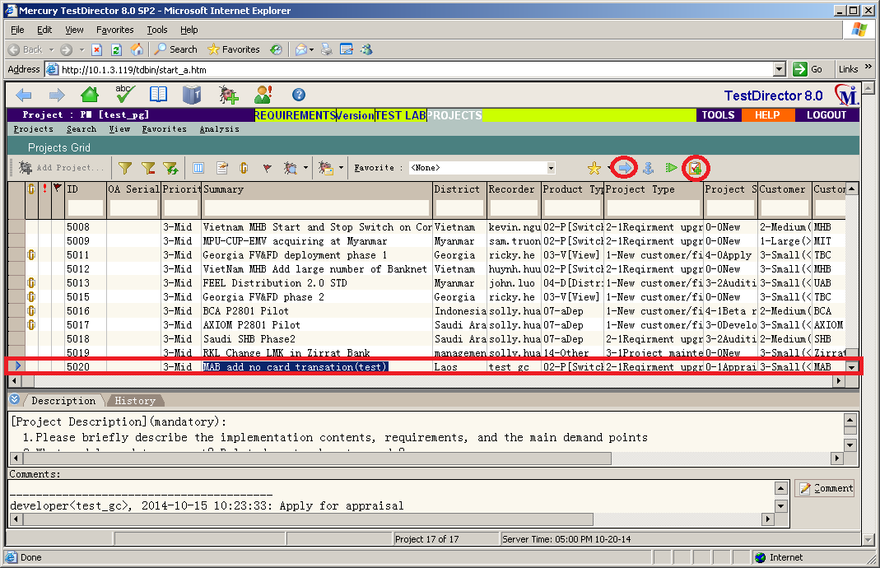

Start to appraise
Click “Next Step” or ”Appraise” button, display as follow:
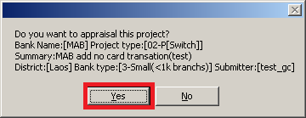
Click “” to begin appraising of the project.

Enter appraisal workload
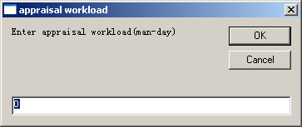

Input the notation messages

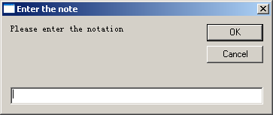
Click “OK” button, the appraising is finished, and the project status will be changed into “0-2Appraised”

Start a project (Engineer)

Locate project
After the project is appraised, the engineer can start the project.
Click the drop down list of the favorite, and select the “Register View”.
Find your project and move the cursor bar to the record.

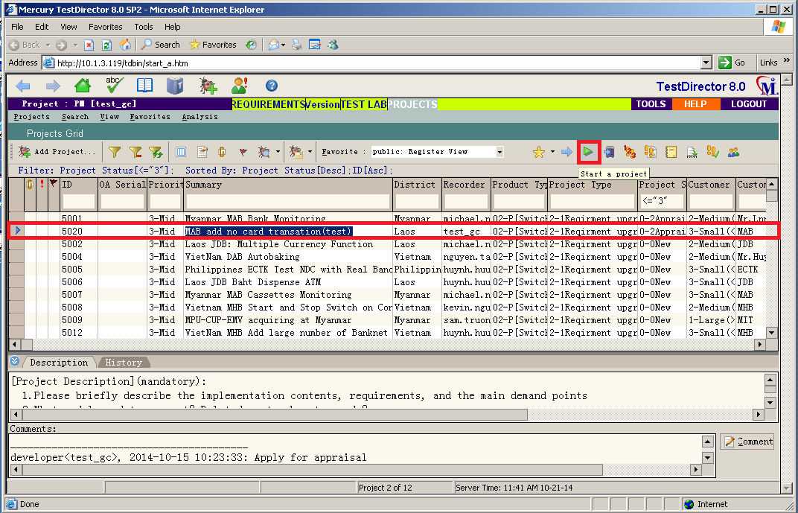

Execute "Start a project" wizard
Click “Next Step” or”Start a project” button, display as follow:
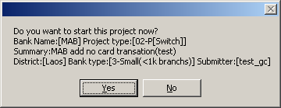

Input planning submit date
Click “Yes” to start a project, and input the planning submit test date, as follow:
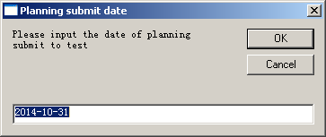

Input the notation messages

Input some notation messages, and click “OK”, then the project is stated:

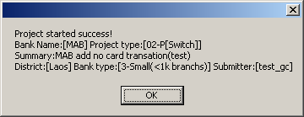

Attentions after started
System will be prompted attentions in the process of development:
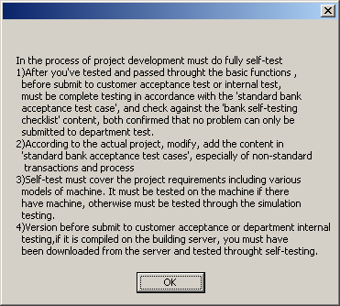
After you confirmed and clicked “OK”, the project status is changed into “3-0Developing & selftesting”.

Selftest promise (Engineer)

Locate project
Click the drop down list of the favorite, and select the “Developing View”.
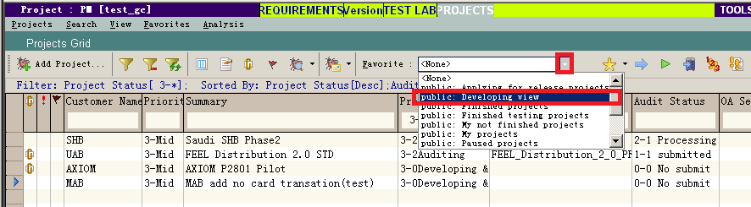
Find your project and move the cursor bar to the record.

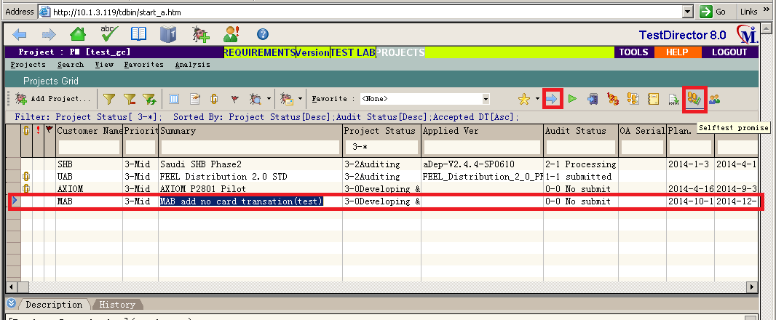

Execute "Selftest promise" wizard
Click “Next Step” or”Selftest promise” button, display as follow:
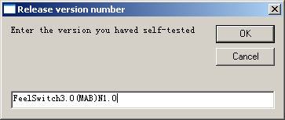
Enter your version number, and click “OK” to continue.

Confirm selftest promise
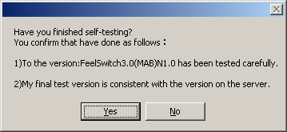
If click “Yes” the project status will be changed to “3-1Finished Selftesting”.

Submit to audit (Engineer)

Locate project
Click the drop down list of the favorite, and select the “Developing View”.
Find your project and move the cursor bar to the record.

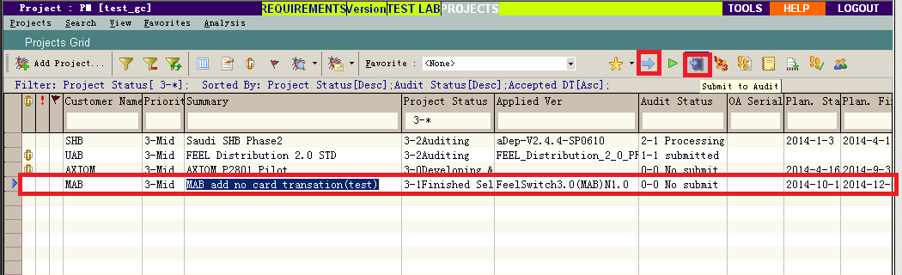

Execute "Submit to audit " wizard
Click “Next Step” or ”Submit to audit” button, display as follow:
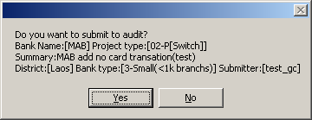
Click “Yes” to confirm your execution, and display as follow:

Confirm before submit
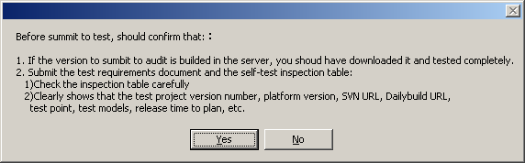
Click “yes” to continue.

Input platform version
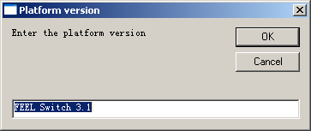
Enter the platform version of the project.

Input engineering version
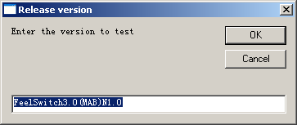
Enter the engineering release version of the project.

Confirm version named specification
System will prompt the version named specification as follow:
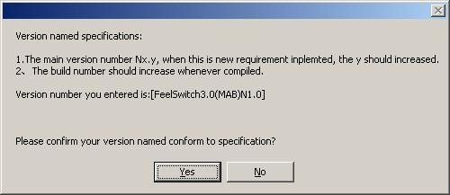
If your version is conform to the specification, click “Yes” to continue, otherwise click “No” to cancel and reinput the version name. When click “Yes” display as follow:

Select the package to test
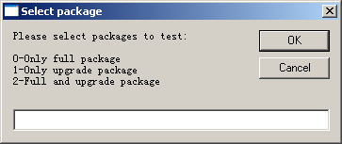
To select the packages wanted to test. You can select 0, 1 or 2, and click “OK”.

Input SVN URL
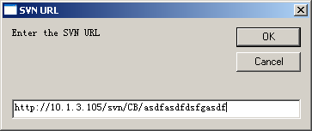
Enter the Source Control Server’s URL where to access you project source code.

Input Dailybuild URL

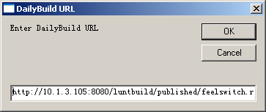
Enter the Daily-build server URL where to download the program for test.

Input required to complete days

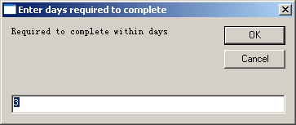
Input within how many required to complete test.

Input machine model to test
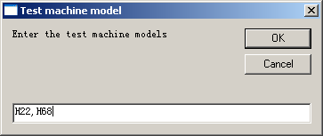
Input what model machine should be test.

Reconfirm all message
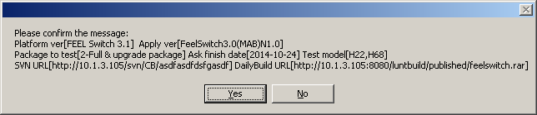
Reconfirm the messages you just inputted in.

Enter the notation
Input more natation for reference.
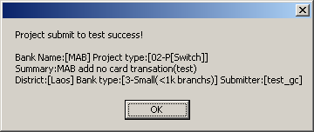
The project status will be changed into “3-2Auditing”.

Upload Attachment
You can upload the document related to the project to the server if necessary.
Step 1: Click icon on the menu bar

Step 2: Select the document to upload.

Code review (Code reviewer)

Locate project
Click the drop down list of the favorite, and select the “Testing View”.
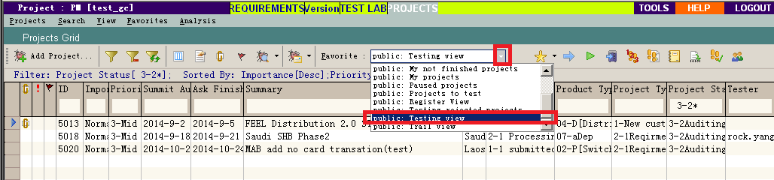
Find your project and move the cursor bar to the record.

Start code review
Before start to do code review, you are required to verify whether enough attachments have been submitted, such as: self-test logs, testing requirements book, project checklist, etc.
To start code review, Click “Next Step” or button, display as follow:
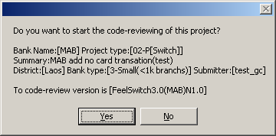
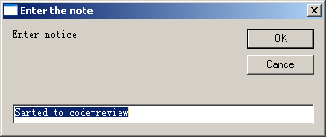
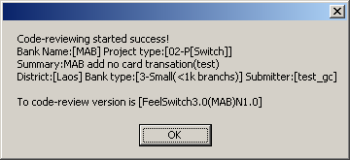
The project’s “code view result” value will be changed to “1-Processing”.

Finish code review
The code viewer will download the project source code, document, etc. from the place that project saved, and will check the validity, rationality and correctness of the code and document.
If problems is found, they will be registered in the Test BUG management system. Finally the code view should make a conclusion for the code-reviewing of the version: pass or not pass.

To finish code review, Click “Next Step” or button, display as follow:
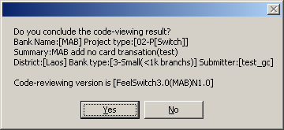

Click “Yes”, and select your conclusion:
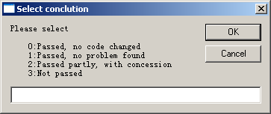
Input your selection. If you entered 0,1 or 2 means the code view result is ‘Passed’. If you entered 3 means not passed.

Enter the notation:
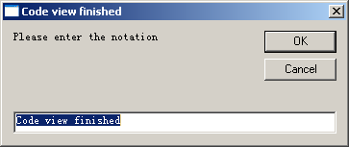
Click OK
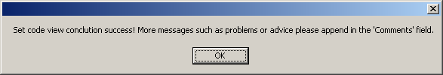

Upload Attachment
You can upload the document related to the project to the server if necessary.
Step 1: Click icon on the menu bar

Step 2: Select the document to upload.

Internal Test (Tester)

Locate project
Click the drop down list of the favorite, and select the “Testing View”.
Find your project and move the cursor bar to the record.

Start internal test
Before start to test, you are required to verify whether enough attachments have been submitted, such as: self-test logs, testing requirements book, project checklist, etc.
To start code review, Click “Next Step” or button, display as follow:
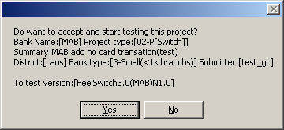
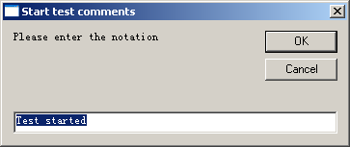
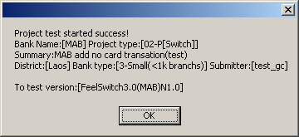

The project’s “Test result” value will be changed to “1-Processing”.

Finish testing
The tester will download the project program package, document, etc. from the place that project saved, and will check the validity, rationality and correctness of the program and document.
If problems is found, they will be registered in the Test BUG management system. Finally the tester should make a conclusion for the testing of the version: pass or not pass.

To finish testing and make a conclusion, Click “Next Step” or button, display as follow:
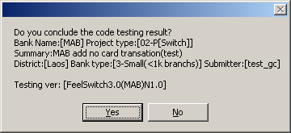
Click “Yes” to continue.
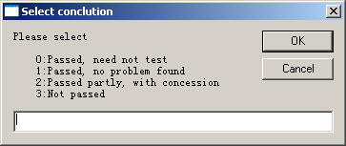
Select conclusion.
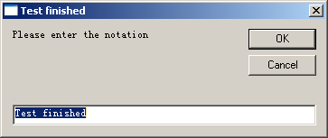
Enter notation.
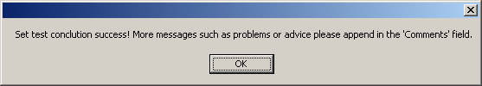
If either test result or code review result is ‘Not passed’, the project status will be change back to ‘3-0Developing & selftesting’. If both test result and code review result is ‘passed’, then project status will be change to ‘3-3Audit passed’.

Upload Attachment
You can upload the document related to the project to the server if necessary.
Step 1: Click icon on the menu bar

Step 2: Select the document to upload.

Apply for beta release (Engineer)
When both test result and code review result is ‘passed’, then project status will be change to ‘Audit passed’, and you can apply you version for trail release or general release.
In general, if the version has no code changed, it can be apply for general release directly, otherwise it should be apply for beta release first, run and tracked after a period of time, when there is no problem can be applied for general release.

Locate project
Click the drop down list of the favorite, and select the “Finished testing projects”.
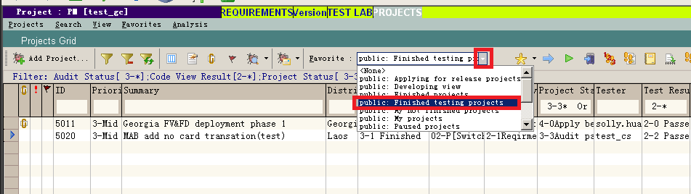
Find your project and move the cursor bar to the record.

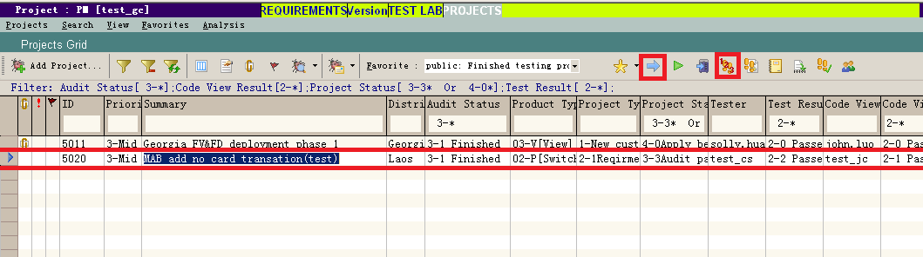

Execute apply for beta release wizard
To apply for beta release you can click “Next Step”, and select “1:Apply for trail“ option, as follow:
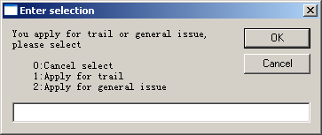
Or, you can click button, display as follow:
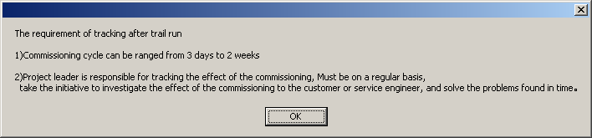
Shows the requirement of tracking after beta release.
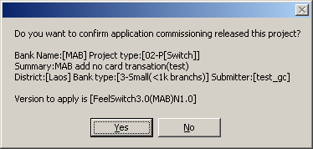
Click “Yes” to confirm you selection.
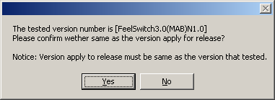
Confirm the version number to release. It should be same as the version applied to test.
Click “Yes” to continue, “No” to cancel.
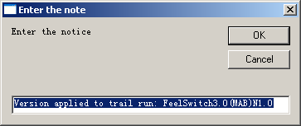
Enter notation.
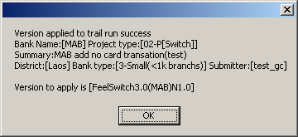

Upload Attachment
You can upload the document related to the project to the server if necessary.
To release a version, you must upload release notice, installation guide, at least.

Step 1: Click icon on the menu bar

Step 2: Select the document to upload.

Beta release (CM)

Locate project
Click the drop down list of the favorite, and select the “Finished testing projects”.
Find your project and move the cursor bar to the record.

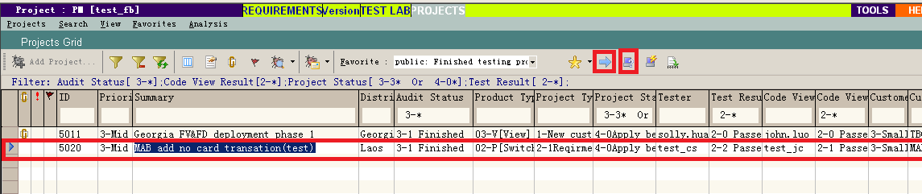

Execute beta release wizard
Click “Next Step” or button, display as follow:
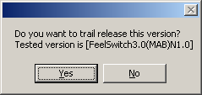
Click “Yes” to continue.
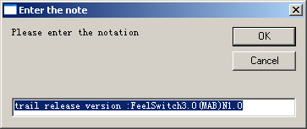
Enter notation for reference.
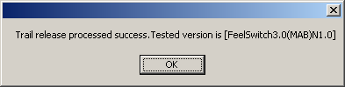
Finished. And the project status will be changed into “4-1Beta released”.

Apply for general release (Engineer)
When both test result and code review result is ‘passed’, then project status will be change to ‘Audit passed’, and you can apply you version for trail release or general release.
During the version in the beta release period, you should tracked the status frequently. If then problems found, you should analyze and correct it, and reapply the version to code review and internal test. If there is no you can be apply it for general release directly.

Locate project
Click the drop down list of the favorite, and select the “Trail view”.
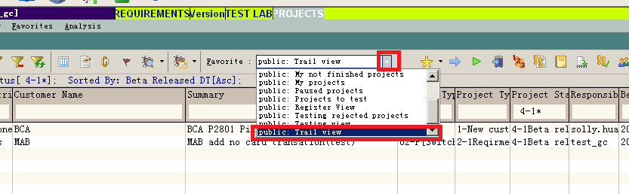
Find your project and move the cursor bar to the record.

Execute apply for general release wizard
To apply for beta release you can click “Next Step”, and select “2:Apply for general issue“ option, as follow:
Or, you can click button, display as follow:
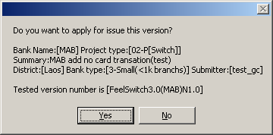
Click “Yes” to continue.
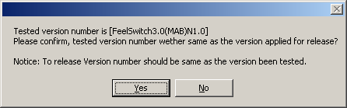
Click “Yes” to confirm you selection.
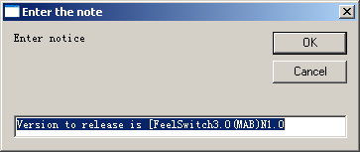
Enter notation.
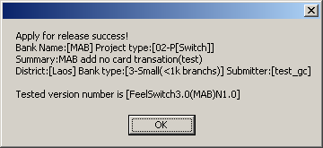

Upload Attachment
You can upload the document related to the project to the server if necessary.
To release a version, you must upload release notice, installation guide, at least.

Step 1: Click icon on the menu bar

Step 2: Select the document to upload.

General release (CM)

Locate project
Click the drop down list of the favorite, and select the “Trail view”.
Find your project and move the cursor bar to the record.
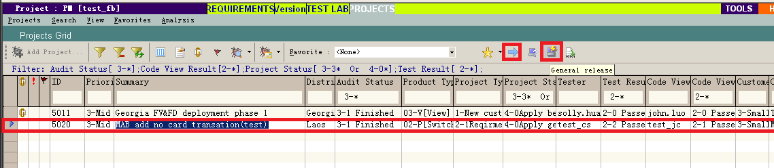

Execute general release wizard
Click “Next Step” or button, display as follow:
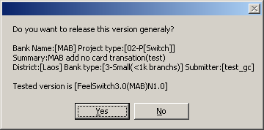
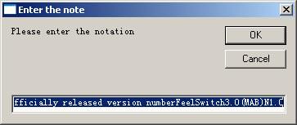
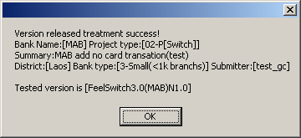

The usage of the convenient tools

Flag for follow up
The "Flag for follow up" button is below the "Defects Grid". Also, it can be found on the "Defects Details" dialog.
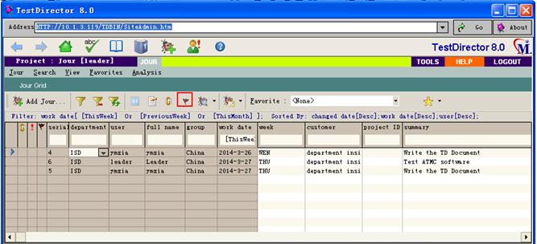

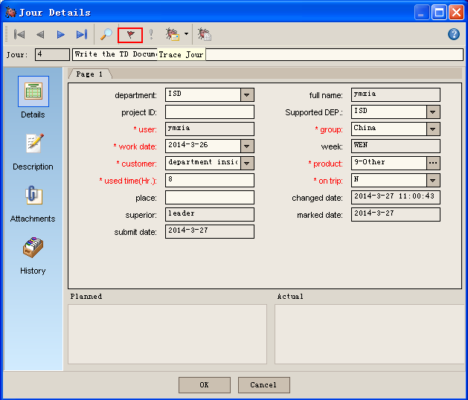
Using this tool, the content written in the “Description” field will be sent to you on the date selected in “Follow up by” field by the email, please refer to the following steps:
Step 1: Click ""， pop up the following dialog:
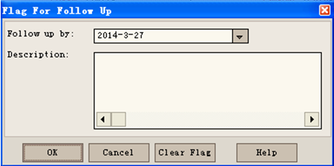

Step 2: Select or input “follow up date”.
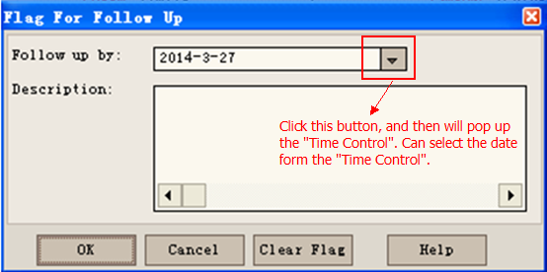
Step 3: Input the reminder content on "Description" field.
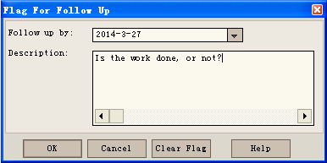
Step 4: Click "OK" to save this flag;
Click “Cancel” to cancel this action and close this dialog.
Click “Clear Flag” to clear all the flags.

Note: When coming to the “Follow up” date, TD system will send an email to the submitter who set the flag. The email will include the project information and the reminder content of the "Description" field.

Set the Filter/Sort.
Can set the filter to display the specified work diary, and can set the sort according to the specified content.
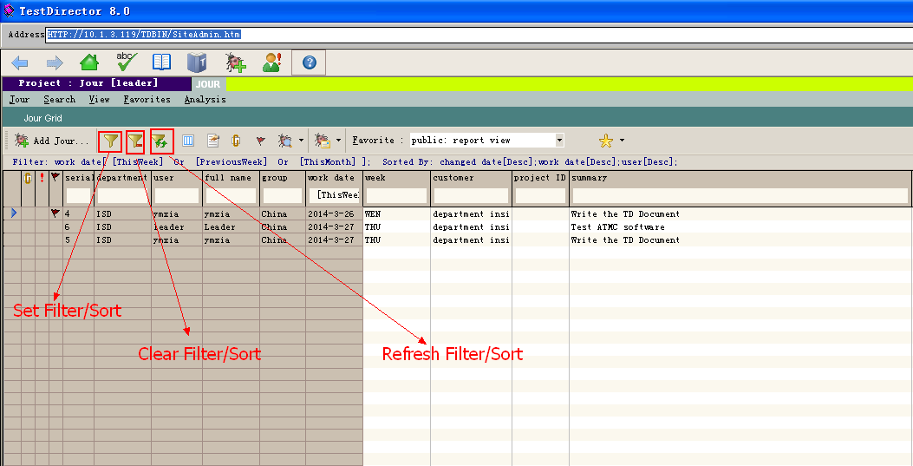
1. Set Filter
Step 1: Click "" to pop up the "Set Filter/Sort" dialog. Then select "Filter" option, as shown below.
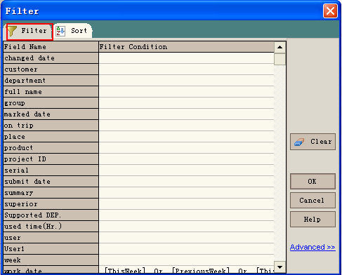

Step 2: Input the "Filter Criteria" on the filter fields.

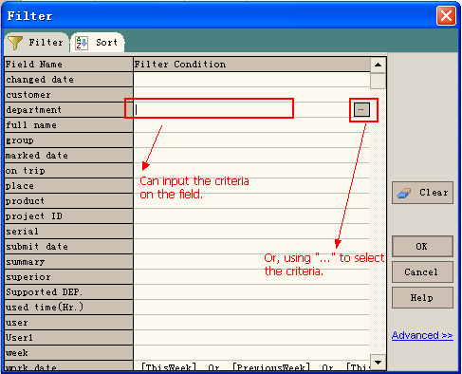

Using “...” to select the criteria:
- Click "..." to pop up the dialog which include some options to be selected, as shown below.
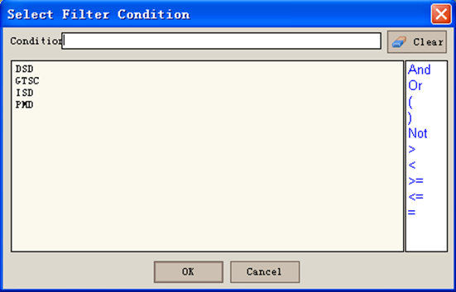

B. The dialog display all the department. Select "ISD", the Department Filter Field will display "ISD":

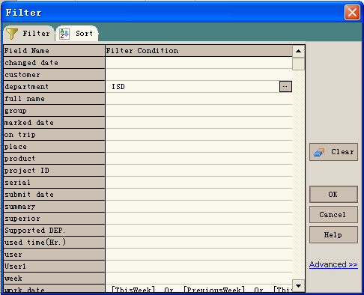

Step 3: Click "OK", system will display the records matched the filter criteria.

2. Set Sort
Step 1: Click "" to pup up dialog, then click "Sort" option on the dialog.
：Add field to sort.
：Remove sorted field.
：Add all the fields to sort.
：Remove all the sorted fields.
Can also set the position of the sorted field to decide which field is the first/Second... field to be sorted, and set the sorted filed which field should be sorted by ascending, which field should be sorted by descending. Please refer to the following picture:

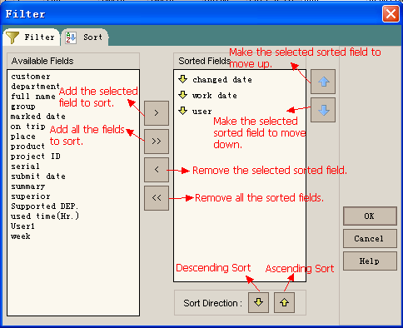

Step 2: Click [OK], system will sort the record according to this sort fields.

3. Clear Filter/Sort
Click "" to clear all the Filter/Sort, and will display all the records.
4. Refresh Filter/Sort
Click "" to refresh all the records matched the current criteria.

Problems and Solutions

How to solve the problem TD email is regarded as the spam email.
The anti-spam function of Our Company's Email Server often regard the email from TD as the spam email. It often put the email from TD to the junk mailbox at server -side, so we cannot receive the email from the TD at our email client.
The solution:
1. Log in our company's email system by inputting "http://www.grgbanking.com/mail/” in the address bar.
2. Set anti-spam level to lower at the anti-spam function.
(Setting->Anti-spam Setting->Current Level: Lower->Save) 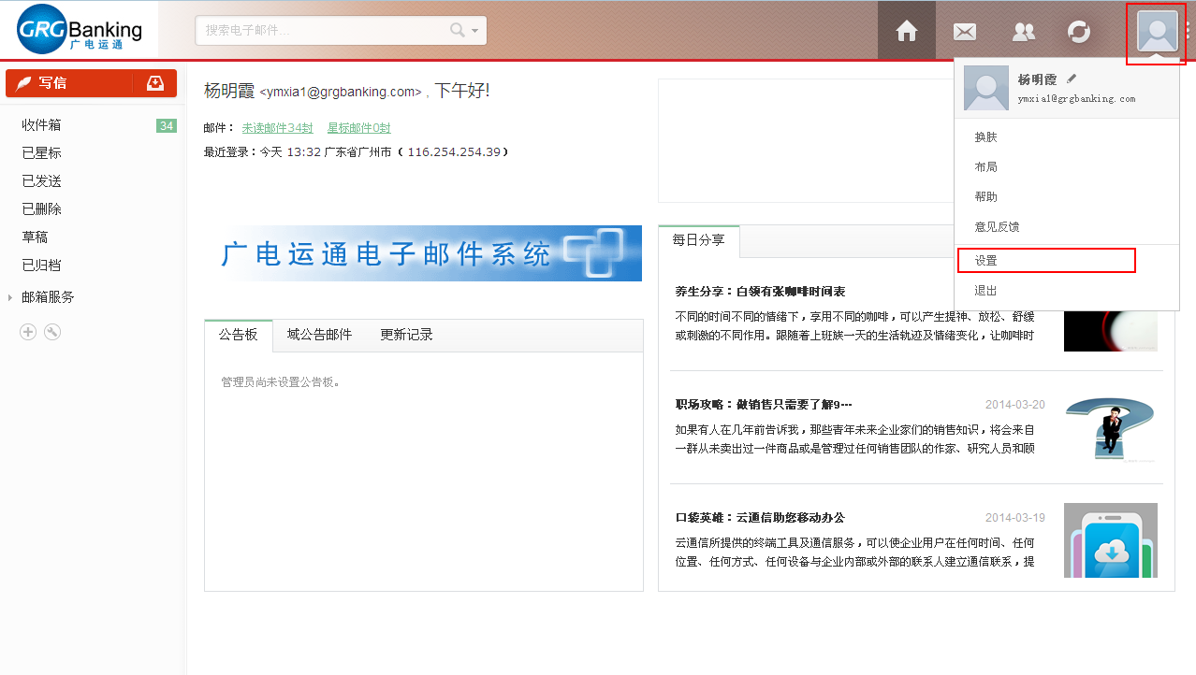
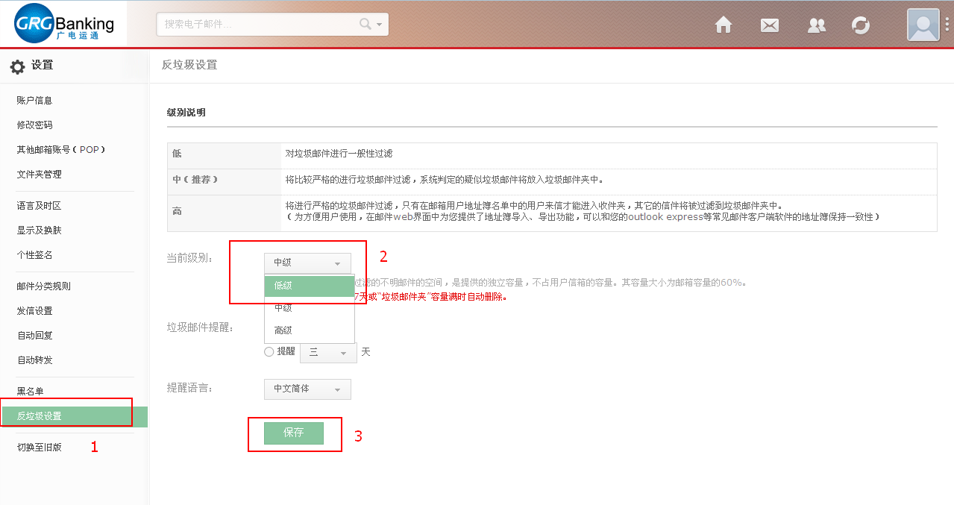

The ways to solve the problem that it cannot login TD using higher version IE.
The higher version IE browser installed in XP OS, or carried by the WIN7 cannot open the TD.
    - The first way to solve the problem.
Step1: We can install "Maxthon" browser to login TD system. After installing the browser, set the configuration like that:

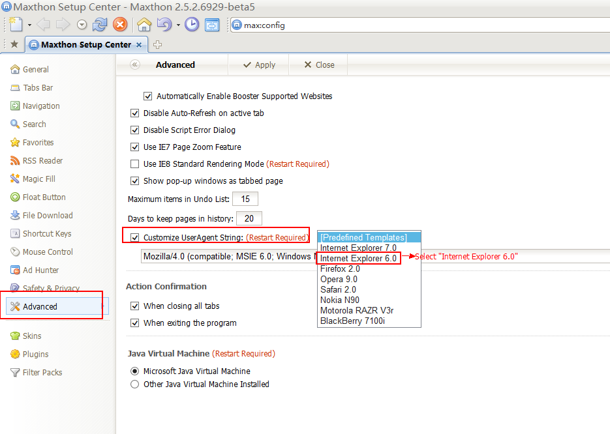
Step 2: Restart the browser, then we can use "Maxthon" browser to login TD system successfully .

    - The second way to solve the problem.
Install TD explorer to login TD.
Step 1: Download TDexplorer8.zip and install it.
Step 2: Run TD explorer.
Step 3: Input TD main page website: http://10.1.3.119/TDBIN/start_a.htm on the TD explorer address bar, click "Go".

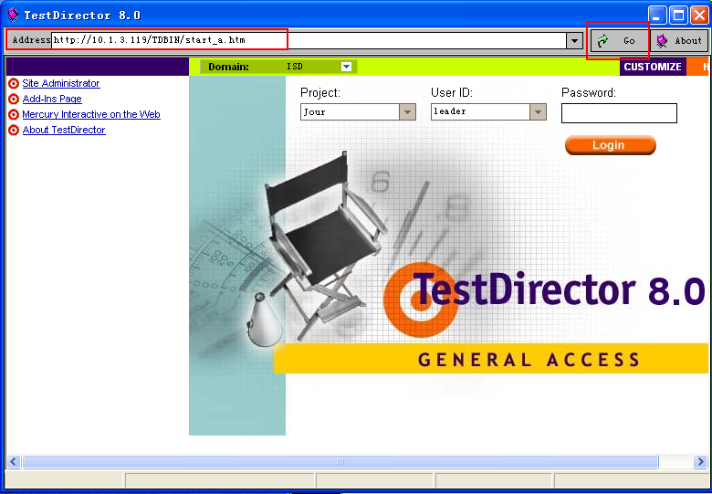

    - The third way to solve the problem.
Change the Internet Options.
Step 1: Click Tool -> Internet Option->Advanced.
Step2: Uncheck the option "Enable memory protection to help mitigate online attacks"
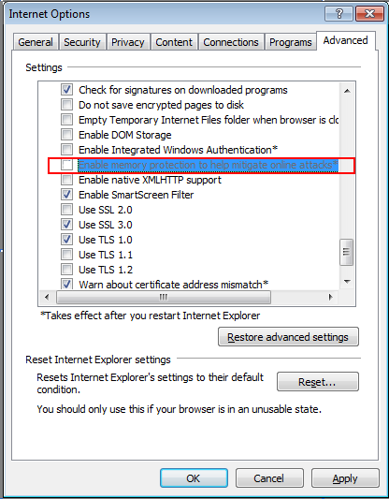
Step 3: Restart IE browser, then we can login TD system successfully.

The solution to solve the problem that it cannot install TD control plug-in under the Browser with the WIN7/VISTA OS environment.
The first time you access TD URL in the Browser, it will automatic download and install the TD Control plug-ins. But in the WIN7/VISTA OS environment the plug-in often cannot install successfully.

The solution: Run your Browser (such as Maxthon, TDexplorer or IE) with the administrator rights, then enter TD URL to download and install the TD control plug-in. Please refer to the picture:
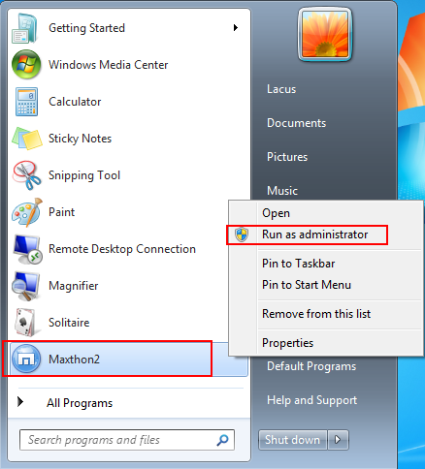

Modify the fields in TD, but the content is not updated.
Sometimes modified fields on TD, but the content of the field is not updated.
The reason: For TD access data using three-tier structure, the data is not real-time updated; Also, when many users using the TD, updating the data at the same time may lead to that some data cannot be updated successfully.
Solution: Suggest that after modifying one TD record, move the cursor to other records. At this situation, the updated content will be submitted to the database.

When updating data, the data is locked by other user.
Sometimes when updating TD record, it will prompt "locked by user...". The locked data will be unlocked in thirty minutes. If you don't want to wait, we can call the administrator to unlock the data.
The way to decrease the chance that the data is locked:
- After updating one record of TD, move the cursor to other records.
- Logout "TD" when not using it as quickly as possible.
- Avoid closing TD without clicking "Logout".

The content of the TD Email is garbled data.
The summary in TD project should not more than 20 characters. Or not, the email will be garbled data.

The reason and solution of the "Access violation" problem.
In the TD system running, it often prompt "Access violation..." message as shown in the picture below. The reason is that Many processed are grabbing the same resource simultaneously. The solution is that avoiding open a lot of windows to log in TD at the same time.
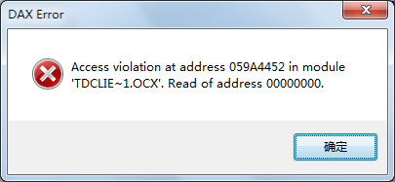

How to find your information quickly.
You can find someone’s work diary from a lot of work diaries. The way is that input search criteria below the corresponding fields, then click “Enter”. Please refer to the following steps.
Step1: Click "" to clear all the Filter/Sort. 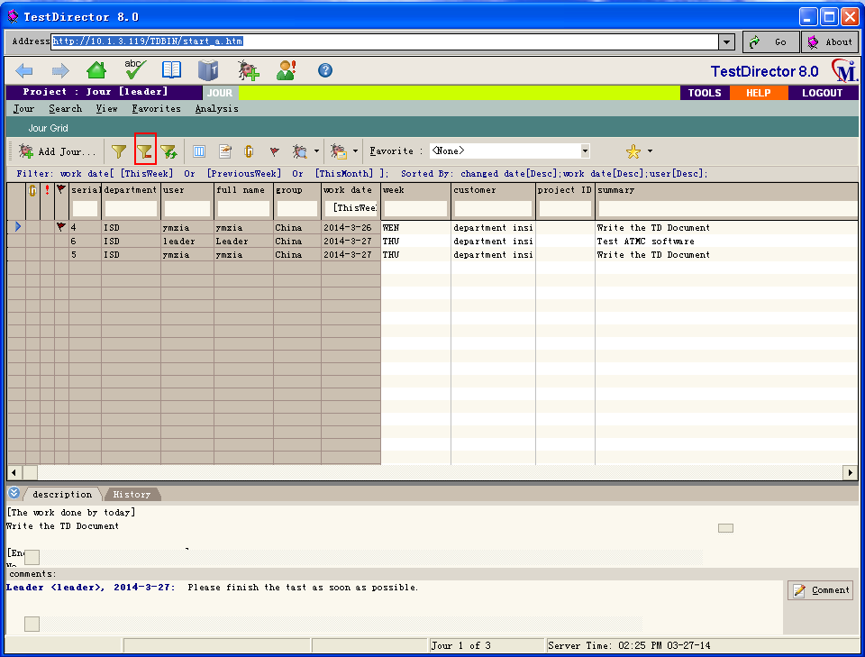
Step 2: Input the criteria below the search criteria, and then click “Enter”. Then the system will display the records matched the criteria.
